**Name & ID**: Basil khowaja **Date:** 01/10/2024

|  |
| --- |
| **EE-424L Data Communication & Networking**  **Fall 2024**  **Habib University**  **Dhanani School of Science & Engineering** |

LAB 6: **Inter VLAN Routing**

|  |  |  |  |  |  |  |  |  |  |  |  |  |  |  |  |  |  |  |  |  |  |  |  |  |
| --- | --- | --- | --- | --- | --- | --- | --- | --- | --- | --- | --- | --- | --- | --- | --- | --- | --- | --- | --- | --- | --- | --- | --- | --- |
| **Lab #6 Marks distribution:**   |  |  |  |  |  |  | | --- | --- | --- | --- | --- | --- | |  |  | **LR2=15** | **LR5=50** | **LR9=15** | **AR4=20** | | **In-Lab Tasks** | **Task 1** | /5 | /15 | /15 | /20 | | **Task 2** | /5 | /15 | | **Task 3** | /5 | /20 | | **Marks Obt.** | **/100** | | | | | |

|  |  |
| --- | --- |
| o**bjectives** | **The objective of this lab is to learn about Inter VLAN routing.** |

|  |  |
| --- | --- |
|  |  |

**Introduction**

In the previous lab 5, we have learned and configured VLANs on Cisco Switches. Below is the network topology every group configured in last lab. As you have seen there is no communication possible in between two different VLANs. This can be done through different approaches listed below:

1. **Traditional Method**

This is an old method and not in use nowadays. In this type of inter-VLAN routing, a router is usually connected to the switch using multiple interfaces. One for each VLAN. The interfaces on the router are configured as the default gateways for the VLANs configured on the switch. For example, if there is 10 VLAN then your router must have 10 physical ports to configure Inter VLAN. For this reason, it is not cost-effective.

1. **Router on a Stick**

Router configuration in which a single physical interface routes traffic between multiple VLAN on a network is called router on a stick. This is the latest method and nowadays every network admin using this method. This method allows you to create sub interfaces on the single port of a router. For example, there is 10 VLAN then unlike traditional method you no need 10 physical port on a router. Instead of this, you can add all the VLAN in the single port of a router itself by creating virtual sub interfaces. (eg: f0/0.1, f0/0.2, f0/0.3, etc)

1. **Layer 3 Switch**

This method allows you to configure Inter VLAN Routing in the switch itself. But, for this, you need layer 3 switches. You cannot configure Inter VLAN on layer 2 switch.

**Switch Virtual Interface (SVI)**

SVI is a logical interface on a multilayer switch that provides layer 3 processing for packets to all switch ports associated with that VLAN. A single SVI can be created for a VLAN. SVI on layer 3 switch provides both management and routing services while SVI on layer 2 switch provides only management services like creating VLANs or telnet/SSH services.

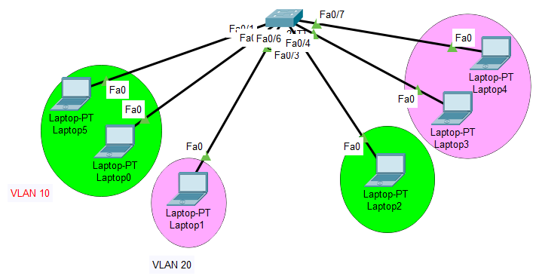

**Task 1: Configure Inter-VLAN Routing using Router on a Stick**

**Steps:**

**Note: All commands, configuration steps and testing screenshots should be reported in Lab Report with Network Topology diagram.**

1. Create below network topology in Packet Tracer

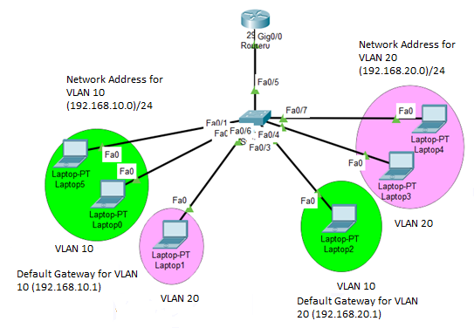

1. Create 2 VLANs on the switch:  VLAN 10 and VLAN 20. You can give them custom names.

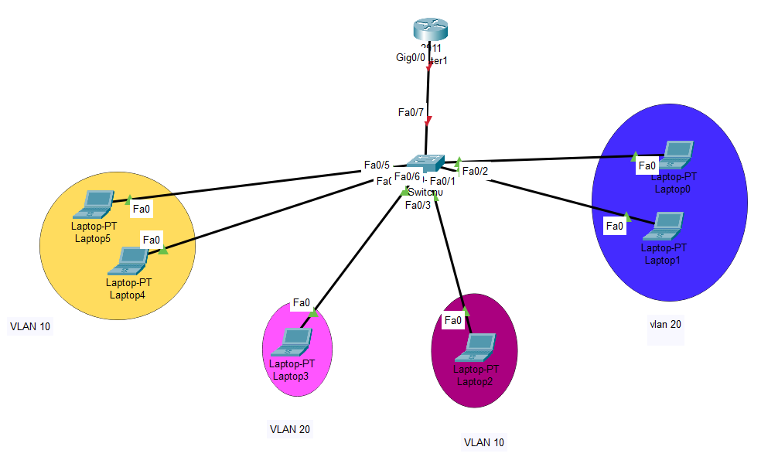

3. Assign switch ports to the VLANs. Remember each VLAN is viewed as separate broadcast domain and just before you configure, have in mind that switch ports could be either access or trunk.

* An access port is assigned to a single VLAN. These ports are configured for switch ports that connect to devices with a normal network card, for example a PC in a network.
* A trunk port on the other hand is a port that can be connected to another switch or router. This port can carry traffic of multiple VLANs.

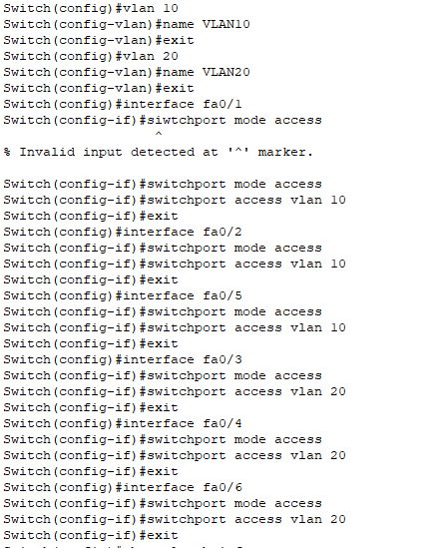

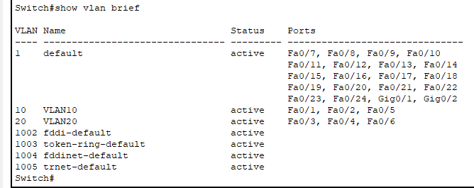

Switch Interface fa0/5 will be configured as trunk port, as it will be used to carry traffic between the two VLANs via the router. Interface fa0/5 is configured as trunk and will be used to for inter-VLAN communication.

**Switch(config)#int fa 0/5**

**Switch(config-if)#switchport mode trunk (in my case it was port fa0/7 so I made it trunk)**



4 **.** Assign static IP addresses to the Six Laptops which are located in the separate VLANs and highlighted by pink and green colors in topology. Laptop 0, 2 and 5 fall in VLAN 10 while Laptop 1,3 & 4 fall in VLAN 20. Remember to assign below gateways for respective laptops in both VLANs.

VLAN 10: default gateway IP (192.168.10.1)

VLAN 20: default gateway IP (192.168.20.1)

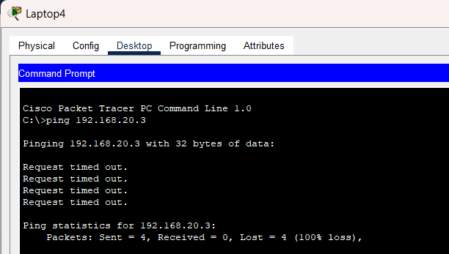

Ping here in different VLAN will definitely fail. Why? Because **inter-VLAN routing** is not yet enabled. Now, in order to allow the hosts in the two VLANs to communicate. We’ll configure the router to permit inter-VLAN communication.

**5. Configure inter-VLAN routing on the router**

We’ll divide the single physical interface on the router into logical interfaces (sub interfaces). Each sub-interface will then serve as a default gateway for each of the VLANs. This scenario is called **router on a stick** (R.O.A.S) and will allow the VLANs to communicate through the single physical interface.

*Note:*  We **can’t**assign an IP address to the router’s physical interface that we have subdivided into logical sub-interfaces. We’ll instead assign IP addresses to the sub interfaces.

**Router(config)#int Gi 0/0/0**

**Router(config-if)#no shutdown**

**Router(config-if)#exit**

**Router(config)#int Gi 0/0/0.10**

**Router(config-if)#encapsulation dot1q 10**

**Router(config-if)#ip add 192.168.10.1 255.255.255.0**

**Router(config)#int Gi 0/0/0.20**

**Router(config-if)#encapsulation dot1q 20**

**Router(config-if)#ip add 192.168.20.1 255.255.255.0**

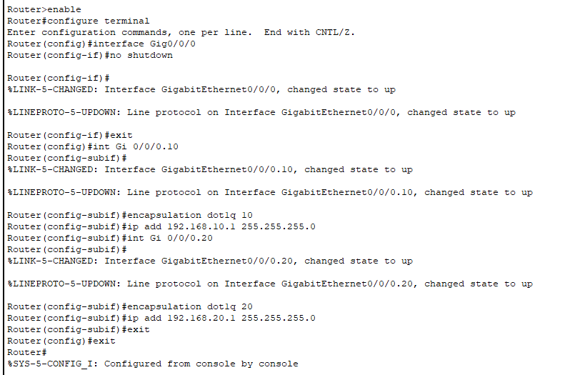

As you can notice from above, the routers physical interface Gi 0/0 is subdivided into two sub-interfaces (Gi 0/0/0.10 and Gi0/0/0.20)*,* which are then configured as *trunk* interfaces and given IP addresses.

Finally, Test **inter-VLAN** connectivity.

Ping Laptop 0 in **VLAN  10** from Laptop 4 in **VLAN 20**.

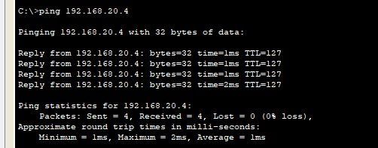

**Task 2: Configure Inter-VLAN Routing using Layer 3 Switch**

**Note: All commands, configuration steps and testing screenshots should be reported in Lab Report with Network topology diagram.**

**Steps:**

1. Create below network topology in Packet Tracer

**Note:**

the Layer 3 switch (3560), is connected to four hosts on different VLANs. Laptop 2 & 3 is in VLAN 10, and PC 2 & 3 is in VLAN 20, as shown below. The Layer 3 switch will provide inter-VLAN routing services to the four hosts.

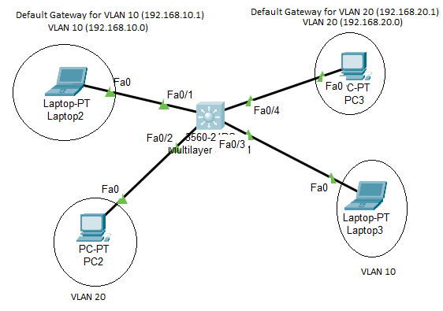

**Topology:**

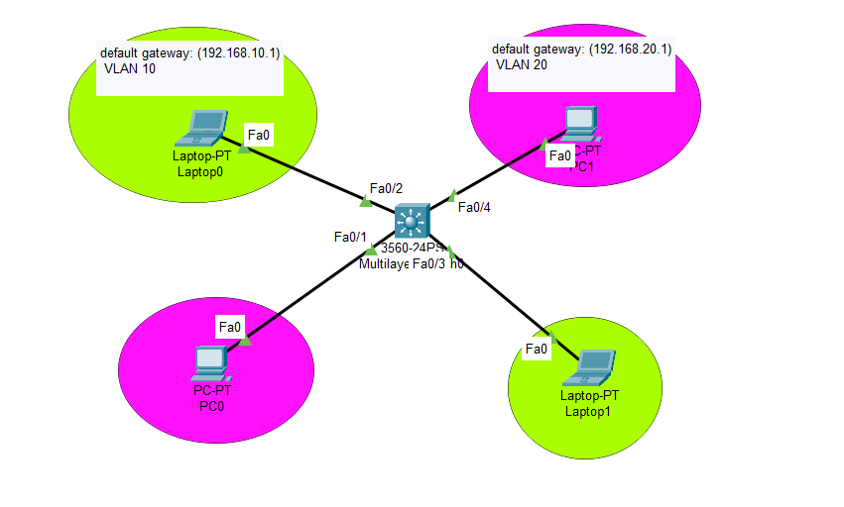

1. Assign IP addresses, subnet mask and default gateway to hosts.
2. **Create the VLAN on Layer 3 switch.**
3. **Create the SVI VLAN interfaces.** Configure the SVI for VLANs 10 and 20 as shown below. The IP addresses that are configured will serve as the default gateways to the hosts in the respective VLANs.

**S1(config)# interface vlan 10**

**S1(config-if)# ip add 192.168.10.1 255.255.255.0**

**S1(config-if)# no shut**

**S1(config-if)# exit**

**S1(config)#**

**S1(config)# int vlan 20**

**S1(config-if)# ip add 192.168.20.1 255.255.255.0**

**S1(config-if)# no shut**

**S1(config-if)# exit**

1. **Configure access ports.** Next, configure the access ports connecting to the hosts and assign them to their respective VLANs. 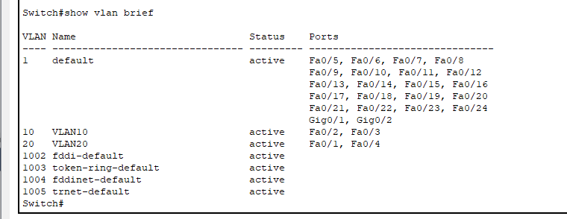
2. **Enable IP routing.** Finally, enable IPv4 routing with the **ip routing** global configuration command to allow traffic to be exchanged between VLANs 10 and 20. This command must be configured to enable inter-VAN routing on a Layer 3 switch for IPv4.

S1(config)# **ip routing**

1. Finally, Test **inter-VLAN** connectivity. Ping Laptop 5 in **VLAN  10** from Laptop 4 in **VLAN 20**.

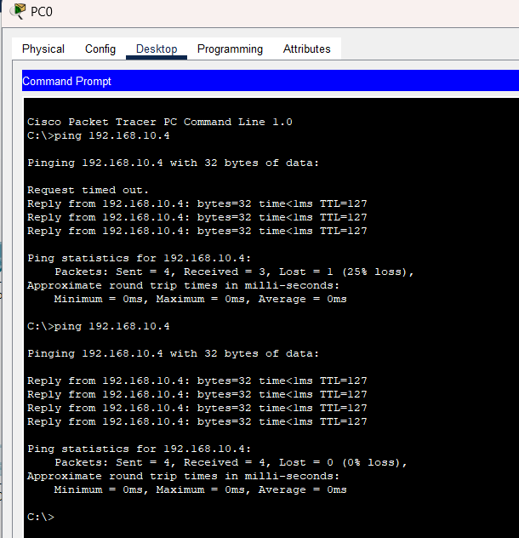

|  |  |
| --- | --- |
| **Task 3:** | **[25]** |

**As you have done half part of below topology using both approaches. Now Configure four VLANs as shown in below topology. Provide all steps and configuration commands for setup of Router/L3 switch and Switches. Attach the Network Topology & screen-shots after checking connectivity between VLANs.**

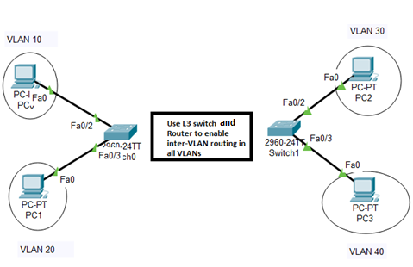

|  |  |  |  |  |
| --- | --- | --- | --- | --- |
| **VLAN No.** | **End Device (PC number)** | **IP address** | **Subnet Mask** | **Default Gateway** |
| **10** | **PC2** | 192.168.10.2 | **/24** | 192.168.10.1 |
| **20** | **PC3** | 192.168.20.2 | **/24** | 192.168.20.1 |
| **30** | **PC4** | 192.168.30.2 | **/24** | 192.168.30.1 |
| **40** | **PC5** | |  | | --- | |  |  |  | | --- | | 192.168.40.2 | | **/24** | 192.168.40.1 |

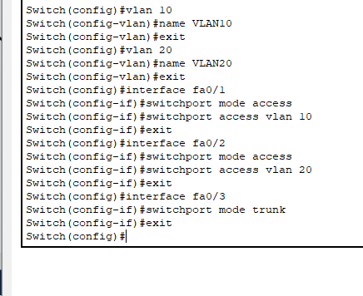

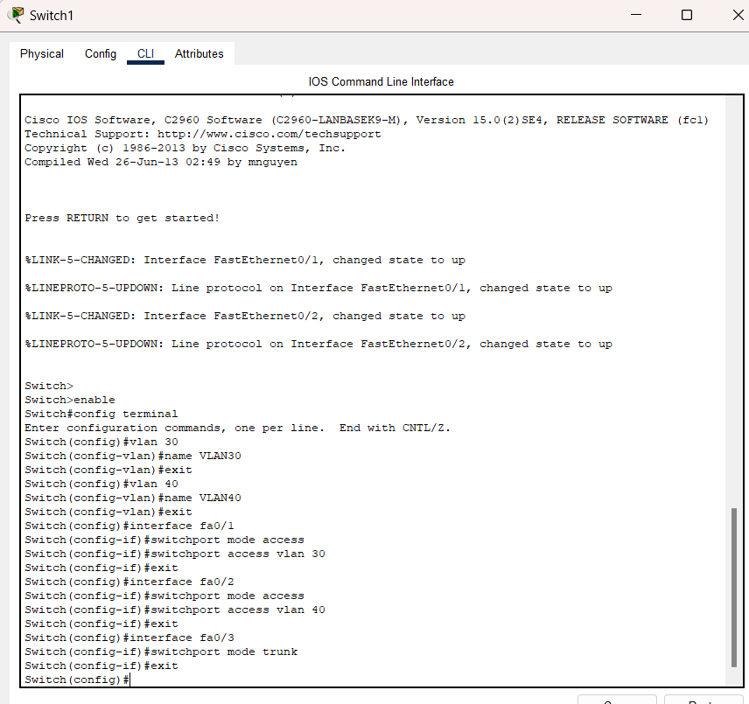

**Step 2: configuring the router:**

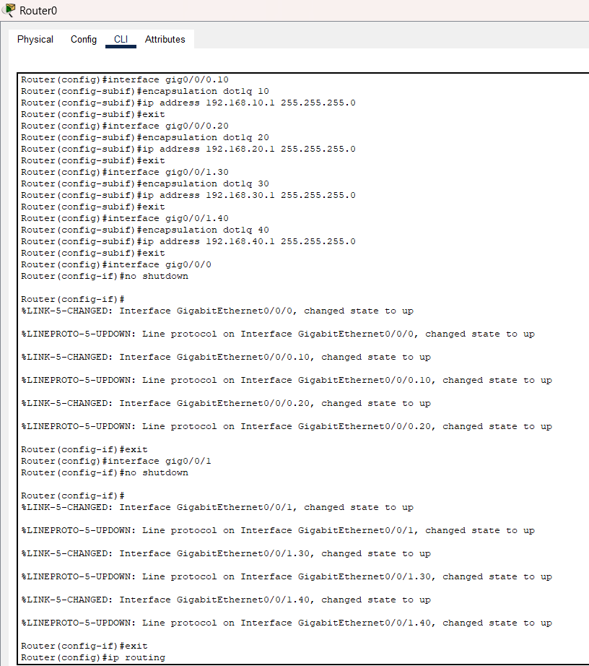

**Step 3: Assigning static ip addresses to pc**

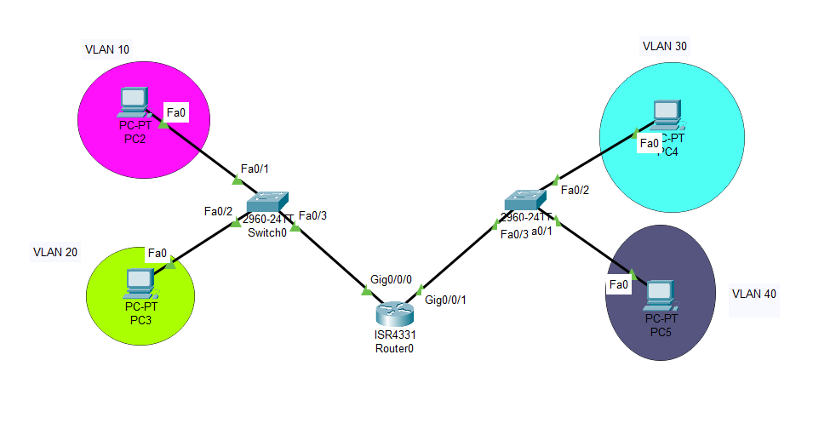

**Pinging from one vlan to another:**



**Lab Evaluation Assessment Rubric**

**EE-424 Lab 6**

|  |  |  |  |  |  |
| --- | --- | --- | --- | --- | --- |
| **#** | **Assessment Elements** | **Level 1: Unsatisfactory**  **Points 0-1** | **Level 2: Developing**  **Points 2** | **Level 3: Good**  **Points 3** | **Level 4: Exemplary**  **Points 4** |
| **LR2** | **Program/Code/ Simulation Model/ Network Model** | Program/code/simulation model/network model does not implement the required functionality and has several errors. The student is not able to utilize even the basic tools of the software. | Program/code/simulation model/network model has some errors and does not produce completely accurate results. Student has limited command on the basic tools of the software. | Program/code/simulation model/network model gives correct output but not efficiently implemented or implemented by computationally complex routine. | Program/code/simulation /network model is efficiently implemented and gives correct output. Student has full command on the basic tools of the software. |
| **LR5** | **Results & Plots** | Figures/ graphs / tables are not developed or are poorly constructed with erroneous results. Titles, captions, units are not mentioned. Data is presented in an obscure manner. | Figures, graphs and tables are drawn but contain errors. Titles, captions, units are not accurate. Data presentation is not too clear. | All figures, graphs, tables are correctly drawn but contain minor errors or some of the details are missing. | Figures / graphs / tables are correctly drawn and appropriate titles/captions and proper units are mentioned. Data presentation is systematic. |
| **LR9** | **Report** | All the in-lab tasks are not included in report. | Most of the tasks are included in report but are not well explained. All the necessary figures / plots are not included. | Good summary of most of the in-lab tasks is included in report. The work is supported by figures and plots with explanations. | Detailed summary of the in-lab tasks is provided. All tasks are included and explained well. Data is presented clearly including all the necessary figures, plots and tables. |
| **AR2** | **Attendance** | Marked attendance and did not attend the lab or left very early. | Present but very late (31-60 minutes) or left early (31-60 minutes) without completing the tasks. | *Present but late (15-30 minutes), or left early (30 minutes) without completing the tasks. | Present and entered the lab on time and left on time. |
| **AR4** | **\*Report Submission** | Late submission after 1 week and in between 2 weeks. | Late submission after 2 days and within a week. | Late submission after the lab timing and within 2 days of the due date. | Timely submission of the report and in the lab time. |

**\*Report:** Report will not be accepted after 1 week of due date